**ALTUI / Local CDN mode**

LocalCDN is mode which enables to use ALTUI on VERA without internet access. All necessary files will be downloaded from another place ( vera or other server you have )

That mode is not recommended for the following reasons:

* You have to update the files in your localCDN repository everytime ALTUI upgrades the version of the files/libraries it uses. That remains you to be in constant sync with ALTUI release and the auto installation of ALTUI will not take care of this for you
* If you do store files on vera, it is more space consumed, more stress on vera when you load the page etc …

But it does work, I have as of today a fully working example in my own setup.

The following document explains how to enable it and what are the file list you need.

# Step1: chose a localcdn location and upload the files

Lets say we decide to put the files under the /www folder of the vera. You will have to make 2 folders, one for script files and one for fonts. The font location is not really controllable so it must be under your /www root. The altui file location is controllable in that case we chose to put it under a altui folder which means the file will be served by the vera web server under http://yourip/altui/<file names>

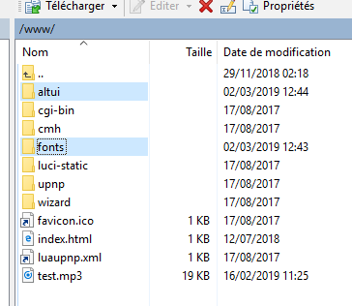

Altui folder must contains the following files:

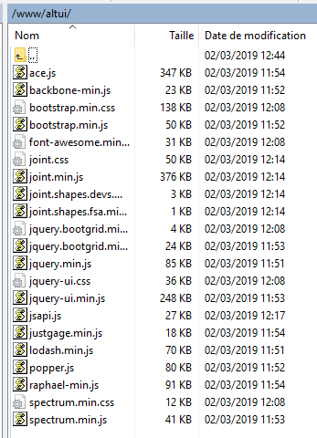

Fonts folder must contain the following files:

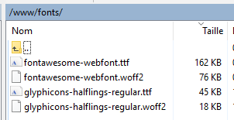

You can find this files at <https://github.com/amg0/ALTUI/tree/master/localcdn> but these are the versions that were the proper ones as of March 2dn 2019 and may have evolved since then.

The files used by ALTUI in normal mode ( non LocalCDN ) are the reference to follow

# Step2: configure ALTUI

The localCDN path must be entered in ALTUI settings as below

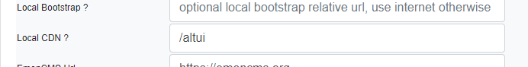

|  |
| --- |
| **NOTE**: In case of trouble ( ALTUI does not load ) , you can go into UI7 to change the LocalCDN variable value. Unfortunately UI7 ui does not let you enter an empty value for a variable which is the normal value for indicating normal ( non localcdn ) mode for ALTUI so ALTUI supports a special value with the character ‘ ~ ’ to mean normal ( non localcdn ) mode. You can enter this in UI7 and you should be back to normal mode |

You can potentially point to another location like your NAS with a full url path ( <http://srv/path> )

As explained the font folder location is not controllable and will have to be under <http://srv/font>s or <http://veraip/fonts> which is /www/fonts on the local vera file system

# Conclusion

Once done properly, altui is able to load all files from that local location as you can see herebelow

